Governor’s Office of Homeland Security

And Emergency Preparedness

State of Louisiana

GOVERNOR DIRECTOR

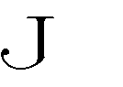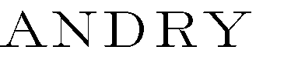

**Louisiana Commission on School and Nonprofit Security**

GOHSEP EOC

7667 Independence Blvd.

Baton Rouge, LA 70806

December 2, 2024 10:00 a.m.

1. CALL TO ORDER – PLEDGE
2. ROLL CALL
3. ADOPTION OF AGENDA
4. OLD BUSINESS
   1. APPROVAL OF SEPTEMBER 2024 MEETING MINUTES
   2. RAVE PANIC BUTTON
   3. UPDATES FROM LCSS
5. NEW BUSINESS
   1. APPROVAL OF COMMISSION POLICIES/ELECTIONS
   2. UPDATES FROM LA-SAFE FUSION CENTER
   3. OPEN FOR ADDITIONAL NEW BUSINESS
   4. PUBLIC COMMENTS
   5. NEXT COMMISSION MEETING DATE
6. ADJOURNMENT

For information on disability accommodations contact Rachel Breaux, Committee Secretary,

7667 Independence Blvd. Baton Rouge, LA 70806; Voice number (225) 925-7500, rachel.breaux@la.gov

7667 Independence Boulevard Baton Rouge, Louisiana 70806 (225) 925-7500 (225)925-7501 An Equal Opportunity Employer